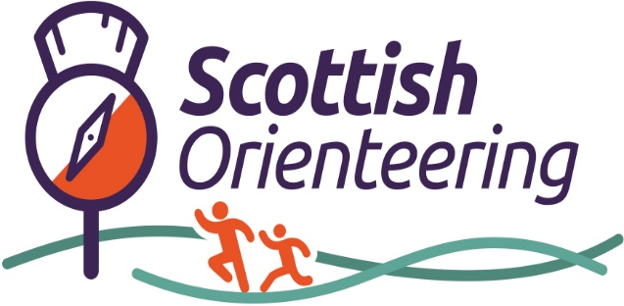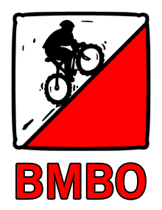

South Scotland MTBO Adventure
Saturday 12th and Sunday 13th July

General

Come and join us for mountain bike orienteering on 2 superb areas. Novices and beginners are welcome.(provided you have a mountain bike!)

On Saturday, come and enjoy the great forest trails at the private Bowhill Estate in the glorious Scottish Borders in this Middle Distance event. This venue was the host of the British Championships in 2023. There's a huge and varied network of tracks and trails, including some tricky singletracks, and one or two hills - spectacular views are guaranteed.

Early on Sunday there is another Middle race at Beecraigs Country Park, a beautiful and hilly woodland area in the Bathgate Hills close to the historic Linlithgow Palace. It has an intricate network of paths and tracks together with dedicated one way MTB trails.

Programme

Saturday 12th July 1030am to 2pm Bowhill House, Selkirk TD7 5ET

Sunday 13th July 7.30am to 10am Beecraigs Country Park EH49 6PL

Classes and Courses

A Long M21-M55.W21-35

B Medium M/W18, M60-65, W40-65

C Short M/W 16, M70+, Novices

Maps and terrain

Bowhill

Scale/Contour: 1:10000 or 1:7500 .5m contour interval
Terrain: Bowhill is dominated by the summit and ridge of Pemassie Hill. A varied and complex track network includes everything from large forest roads to technical hand built singletrack.

Beecraigs

Scale/Contour: 1:10000/5m
Terrain: Undulating hilly woodland with an intricate
network of paths, roads and tracks.

Special Map Symbols and rules

MTB single track trails exist at both Bowhill and Beecraigs that can be used only in one direction, indicated by arrows in magenta. Riding, running, or walking along these trails in the wrong direction will lead to disqualification.

Off track riding is not allowed except in the open areas coloured orange or in forest area shown with black dots. Otherwise, cutting, and off track riding, running or walking is prohibited and infringement of this rule will lead to disqualification.

All competitors will be required to have a bell mounted on handlebars. This is a requirement of landowners’ permissions.

Entries

Entries should be made through the BMBO website www.bmbo.org.uk by Sunday 6th July

Non BMBO members, including international competitors, must first register on the website as a ‘Day Rider’. Instructions for this are as follows:

How to enter a BMBO Event
All entries for the events will be made through the British Mountain Bike Orienteering (BMBO) website.
Riders who are already BMBO members can enter in the usual way.
Riders who are not BMBO members or International riders will have to register with BMBO as a Day member.
Registering as a BMBO member
Visit www.bmbo.org.uk and select Join Now
Towards the bottom of this page, you will see New Adult Day Riders Register Now - Click Here
- Log Details - in You will need to create a User Name and Password
- Select Membership – from the drop-down menu select Day Rider Adult. This free of charge.
- Your Details – fill in your personal details and address details
- For Shield Club select None
- Tick the box I am not a Robot
- Click Submit
You are now registered as a Day Member of BMBO.
Making an Entry
Visit www.bmbo.org.uk
- In the left-hand column select Event Calendar
- Select the event you wish to enter and click Enter
- On the Events Details page click Enter Event
- You will be asked to Login using your User name and Password
- Click Proceed
- Tick the events that you wish to enter
- Select the Course you intend to ride and your Age Class from the drop-down menus
- Click Proceed
- On the summary page select Proceed to Payment or modify your entry
You will now be directed to the payments system.
You can check that your entry has been accepted by going to the Events Details page again and clicking View Entry List
In case of any difficulties please contact: Chairman@bmbo.org.uk

Entry fees

Adult (Day member) £15 per race

BMBO Members £13 per race

Junior (M/W14 to M/W 18 ) £5 per race

Dibber hire £1 per day

There will be limited entry on the day subject to map availability. To avoid disappointment,enter in advance, or if the deadline is missed contact the day organiser by email.

MTBO Safety rules and guidelines

In order to compete safely and fairly in a MTBO event please follow the rules and guidelines as follows:
1. Helmets are mandatory.
2. A serviceable bike is required.
3. You must stay with your bike at all times.
4. You must stay on mapped paths at all times. Riding or running with bikes cross country is not allowed. * See point 21 below regarding the symbols for “permitted to ride”
5. Controls on linear courses must be visited in numerical order.
6. Give way to members of the public on foot or on horseback.
7. When overtaking pass the other cyclist on the right and shout loudly "on the right"
8. In a head on situation both parties turn to the left.
9. Take extra care when approaching roads with traffic. Obey the Highway Code when on a road.
10. Riders travelling uphill must be given priority.
11. At an intersection the rider on the smaller path must give way to the rider on the larger path.
12. Slower riders should give way to faster riders.
13. Take extra care when head down reading the map or approaching another rider head down. Shout warnings as appropriate.
14. Do not loiter at a control site. Use SIAC if possible to speed through controls.
15. Move well clear of the track if stopping for any reason (including reading the map).
16. The events will normally use a punching start and either a punching or SI air finish. Specifics will be given in event details.
17. MTBO maps are similar to foot orienteering maps but contain less detail. There are no form lines and only 2 grades of forest (white - open forest, green -the rest). Many small contour and rock features are not mapped.
18. The main difference from foot orienteering maps is the grading of tracks and paths. Tracks are wide enough for 2 cyclists to pass and paths are narrower and generally difficult for cyclists to pass. Tracks are drawn with thick width black symbol and paths are shown with a narrower width symbol.
19. Tracks and paths are classified into 4 speed bands. Fast (75-100% of possible riding speed on a hard smooth surface). Medium (50 - 75%), slow (25 - 50%) and very slow ((0 - 25%). Fast is shown with an unbroken line, medium with large dashes, slow with smaller dashes and very slow with tiny dashes that look like dots.
20. There are 3 important magenta coloured symbols in use. A dash across a track signifies a hazard - usually a fallen tree that can be crossed with care. If an obstacle cannot be crossed or the track is out of bounds a magenta X will be marked on the track. For one way tracks a magenta V pointing in the allowed direction of travel will be shown.
21. There are 2 symbols that allow for riding off-paths. It is permitted to ride in open areas coloured orange and forest areas shown with black dots.
22. Control descriptions are not used and control codes are printed after the control number on the overprinted map of the course.

Mapboards

For those new to the sport, we will have a limited stock of rotating mapboards for fixing to handlebars available at the events.

Contact details

Bowhill organiser/planner: paul@durtyevents.com

Beecraigs organiser/planner : bob.a.cherry@btinternet.com

BMBO queries: chairman@bmbo.org.uk

Acknowledgements

Thanks to :

Landowners: Buccleuch Estates, West Lothian Council

Maps and support: Forth Valley Orienteers (FVO), Roxburgh Reivers

Scottish Orienteering Association (SOA)

