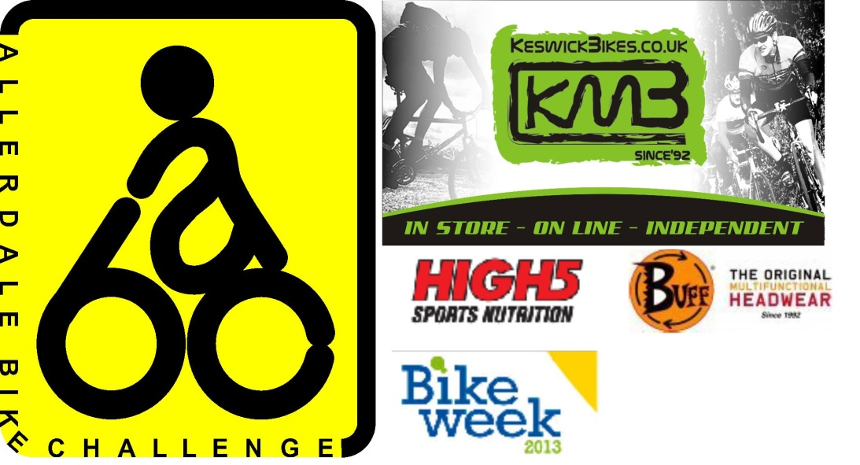
The Allerdale Bike Challenge is a Series of five events on Wednesday Evenings.
These events are a fun and challenging way of exploring the quieter lanes of Allerdale.

The challenge for each rider or group is to decide how many of the checkpoints on the map they can visit in the two hour time limit.

All the routes will all be on tarmac, and will avoid the big climbs of the Lake District. The events are aimed at riders of all abilities and can be ridden solo, in pairs or small family groups on any style of bicycle.

As there is a time limit and no set route the challenge is as easy or tough as you want it to be, making it equally suitable for hardened cyclists or 'Come and try it ' riders.

Proceeds from the events will be used to support local charities.

There will be refreshments available at all events.
THe Challenge EVENTS:
22nd May – Wheatsheaf Inn, Lorton (Grid ref 152260)
5th June – Mill Inn, Dearham (Grid Ref: 076359)
19th June – Mae’s Tea room, Uldale (Grid ref 256367)
2nd July – Fox & Hounds Ennerdale Bridge (Grid ref 068476)
16th July – Bank Mill Nursery, Mawbray (Grid Ref: 086476)

There will be prizes for the winners of the challenge series. The may also be spot prizes on the night.
It will be a rider’s best 3 scores from the 5 events that count for the series.
Results and an updated series league table will be displayed on the BMBO website

Start TimeS

yOU CAN START aNY TIME BETWEEN 5:30 AMD 6:30 PM

CLASSES
• Male solo or pairs
• Female solo or pairs
• Mixed pairs
• Juniors (16 - 17 yrs)
• Generation pairs or groups (must consist of at least one rider over 18 and one rider under 16)

ENTRY FEES

£6.00 (BMBO Member) / £7.00 (Day Rider)

One U16 rides free with a fee paying adult (Generation team),

All other U18 & U16 riders £2

SI Card hire £1. Entry on day + £1.

You can pre-enter online at www.bmbo.org.uk or on the day. Pre-entries close two days before each event.
Note that there will only be a limited number of maps available for on the day entry.
You can join BMBO and receive discounted entry to all BMBO events at www.bmbo.org.uk.
Membership is £6.00 and valid until 31st December 2014.

What to do now….
Pre enter online at www.bmbo.org.uk or on the day. Non-BMBO riders become Day members of BMBO (British Mountain Bike Orienteering) for the day to cover your insurance.
Arrive in plenty of time to get yourself ready, especially if this is your first event. Go to registration first to sign in. You will also be able to collect an SI card if you have hired one.
When ready go to the start and you will be given a pre-marked 1:50,000 Ordnance Survey map extract of the area. This will show the location of the 20 checkpoints and any other important information such as out of bounds roads etc. You can start anytime between 5:30pm and 6:30pm.
You now have TWO hours to plan and ride a route that collects as many of the checkpoints as possible. Make sure that you are not late back as there are penalties! You need to plan carefully so that you know when to give up and head for home!
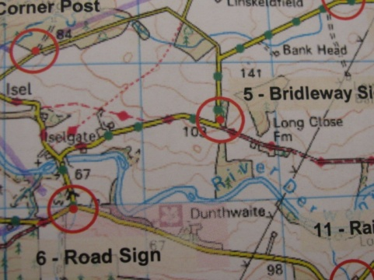

A sample map extract.

All of the checkpoints are attached to footpath / bridleway finger posts or road signs and are worth 10 points each.
To prove you have been to a checkpoint you will need to insert the SI card in to the hole on top of the control box which is attached to the sign with a long steel cable. There is also a numbered red and white plastic orienteering flag attached to help you spot the checkpoint more easily. If the control box does not bleep and flash when you insert the SI card make a note of the 3 letter code that is written on the box to prove that you have been there.
When you cross the finish line insert your SI card into the finish box. You must then go to registration to down load the SI card and receive an instant printout of your score. If you hired an SI card it must be returned to registration. Lost SI cards are charged at £25.

You will need…….
- A road worthy Bike.
- Puncture repair kit
- Basic first aid kit
- An approved cycle helmet
- Bright coloured clothing is a good idea.
- A Mobile phone for emergency use
- A Map board, ideally with a swivel, but a simple piece of board zip tied to your handlebars makes it easier and safer.
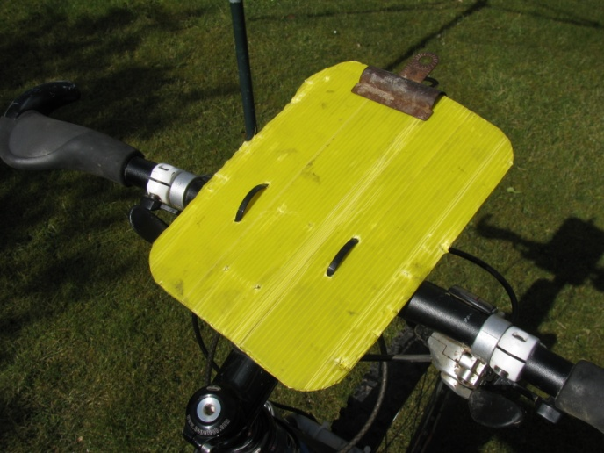
- Highlighter pen to plan your route is useful.

A simple, cheap and safe way to carry your map.
If you have any other questions please email Tony on mbo@bmbo.org.uk.

